Guideline: Installation TyreTag ON PPC

Purpose:
The purpose of this guideline is to enable to install TyreTag on some PPCs device.

Prerequisites
Before initiating the upgrade, ensure the following:
- The device is enrolled in Microsoft Intune.
- The device is actively syncing with Intune.

Step-by-Step Upgrade Procedure

Step 1: Add Device to Update Group
- Locate the target device(s) in Intune.
- Add them to the Intune group:
YTWS.Win11.Upgrade.Immediate
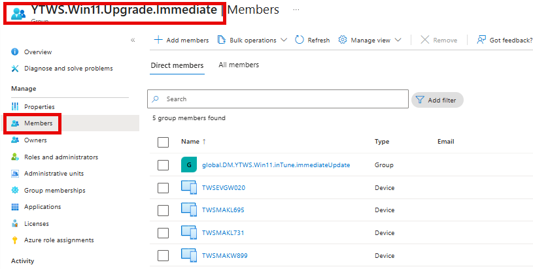

- This group is linked to a Feature Update deployment policy that will trigger the upgrade process.

Step 2: Wait for Update Notification
- Within a few minutes, the end user will receive a Windows Feature Update prompt.
- 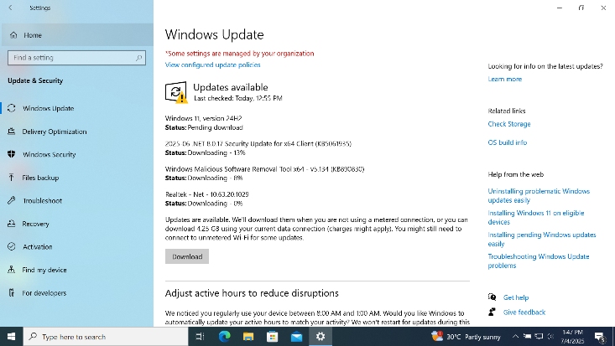
- The prompt will notify them that Windows 11 is available for installation.
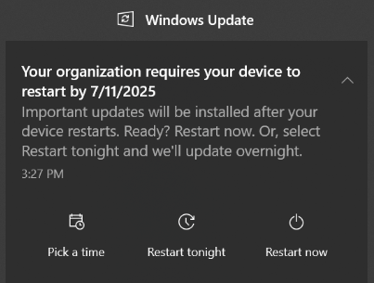
- The prompt will notify the user that Windows 11 is available for installation
Click “Download” to begin the upgrade.
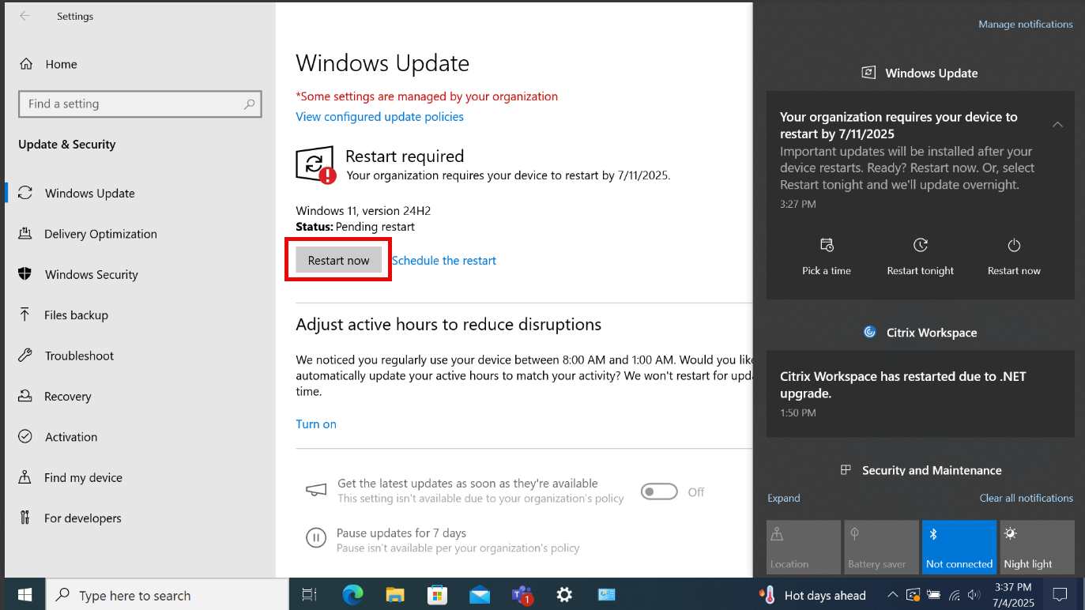
Note: The installation process may require multiple reboots to complete successfully.

Troubleshooting Tips
If the user does not receive the update prompt:

Option A: Manually Sync Device
- Go to Settings > Accounts > Access work or school.
- Select the connected work account.
- Click “Info”, then “Sync”.

Option B: Manually Check for Updates
- Go to Settings > Windows Update.
- Click “Check for updates”.
- By clicking download Windows 11 Feature Update should begin downloading.
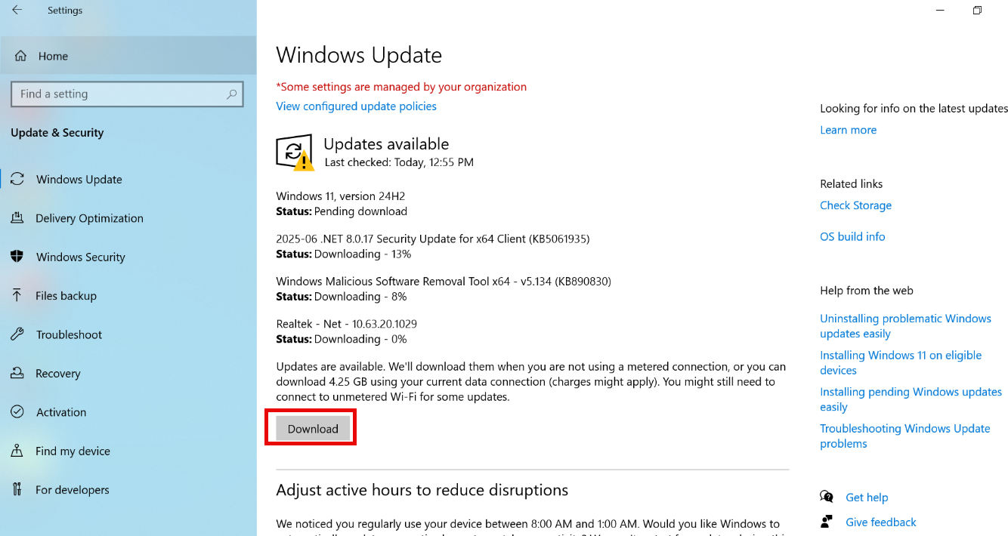
- Note : Ensure the device meets Windows 11 hardware requirements (TPM 2.0, Secure Boot, etc.).
If the device is not eligible, escalate to the regional manager for hardware replacements.

